**CLASS ACTIVITY**

**Common Windows CLI Commands**

**Display command help from the command prompt.**

1. At the command prompt, type **help** and press **Enter**. A list of commands is displayed.

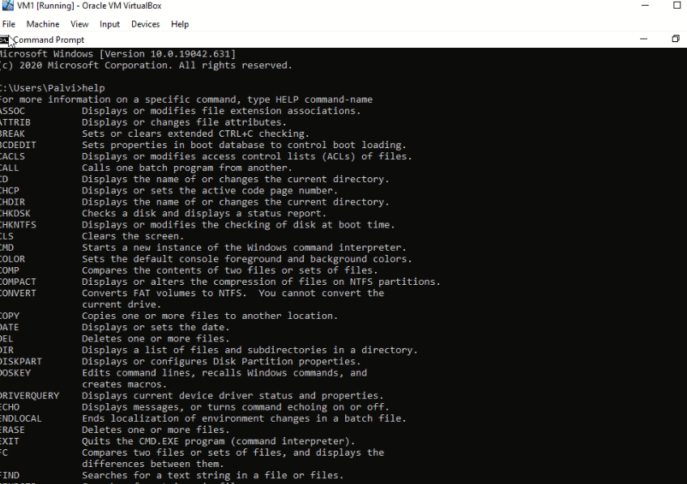

Using the information displayed by the help command, explain the functions of the following commands:

|  |  |
| --- | --- |
| **Command** | **Function** |
| **CD** | Displays the name of or changes the current directory. |
| **COPY** | Copies one or more files to another location. |
| **DEL** | Deletes one or more files. |
| **DIR** | Displays a list of files and subdirectories in a directory. |
| **EXIT** | Quits the CMD.EXE program (command interpreter). |
| **MD** | Creates a directory. |
| **RD** | Removes a directory. |
| **ROBOCOPY** | Advanced utility to copy files and directory trees |
| **SHUTDOWN** | Allows proper local or remote shutdown of machine. |
| **XCOPY** | Copies files and directory trees. |

1. Type **md /?** at the prompt to display additional information and switches that can be used with this command.

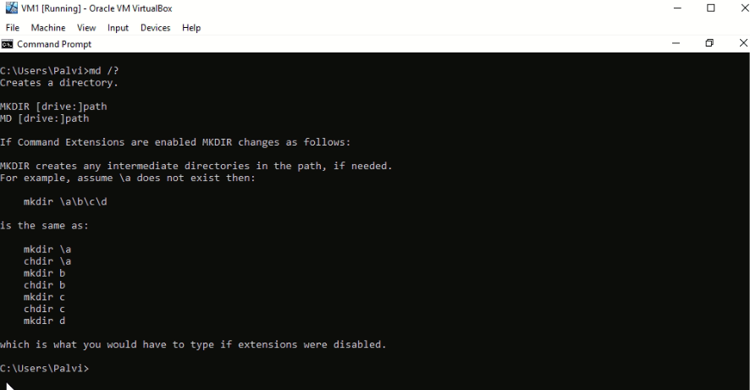

**Create and change directories.**

1. Type **cd** at the command prompt. What is the current directory?

The following image shows that current directory is **c:\users\palvi**

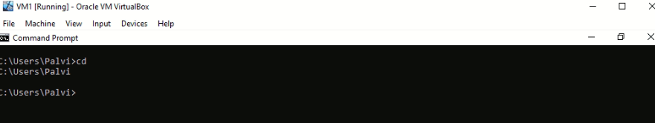

1. Type **dir** at the command prompt to list the files and folders that are in the current folder.

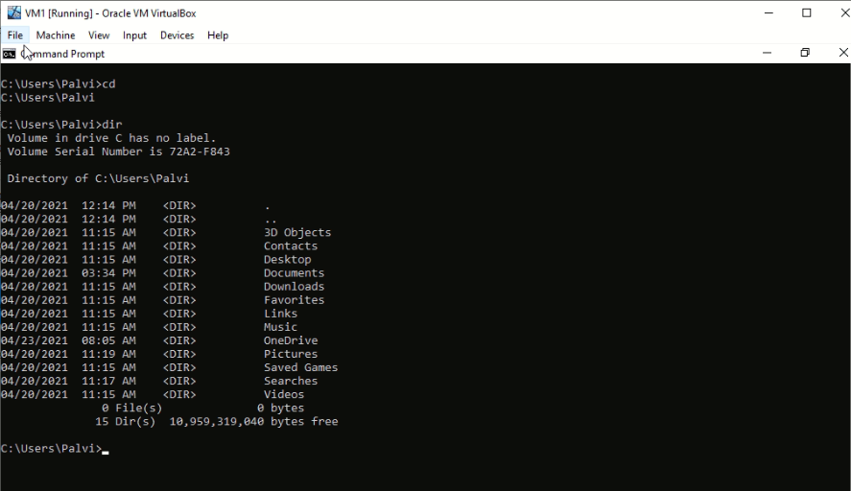

1. Create three new folders: **ITEfolder1**, **ITEfolder2**, and **ITEfolder3**.

md ITEfolder1 is used to create a folder. The following image shows the folder created.

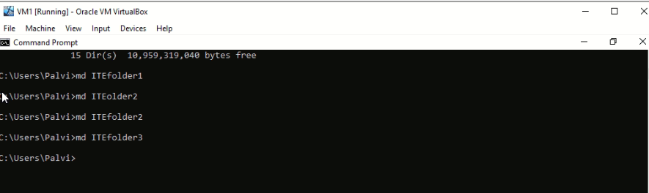

1. Type **dir** to verify the folders have been created.

The arrow shows the created folder named ITEfolder1, ITEfolder2, ITEfolder3

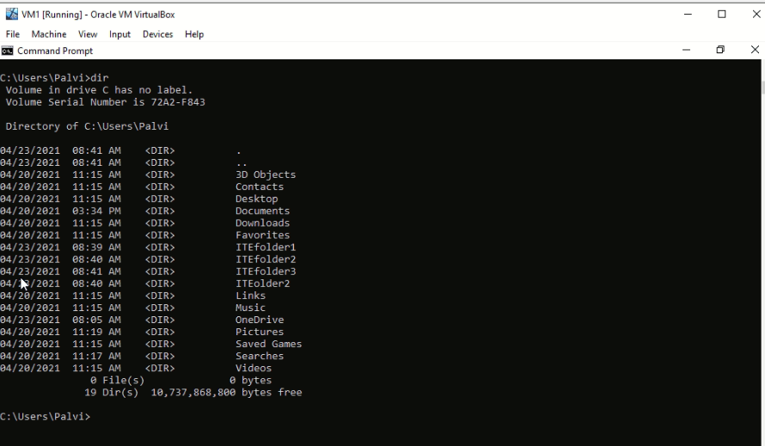

1. Type **cd ITEfolder3** at the command prompt and press **Enter**. Which folder are you in now?

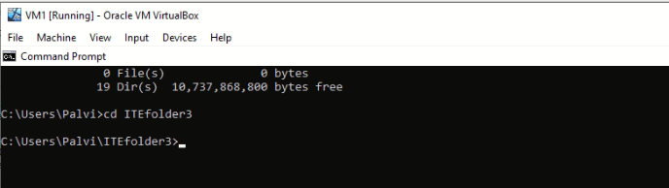

1. Within the **ITEfolder3** folder, create a folder named **ITEfolder4**. Use the **dir** command to verify the folder creation.

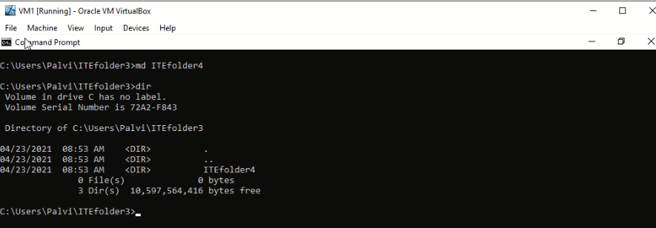

1. Type **cd ..** to change the current directory.

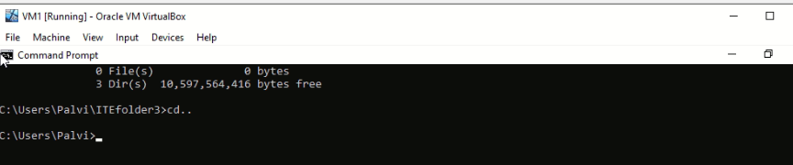

What would be the current directory if you issue this command at C:\Users\ITEfolder3?

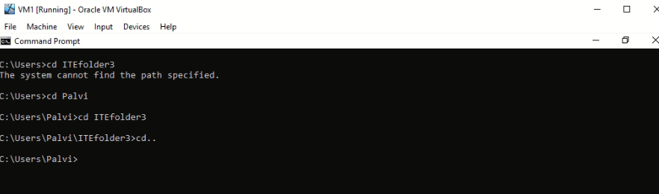

**Create text files.**

a. Navigate to the **C:\Users\ITEUser\ITEfolder1** directory. Type **cd ITEfolder1** at the prompt.

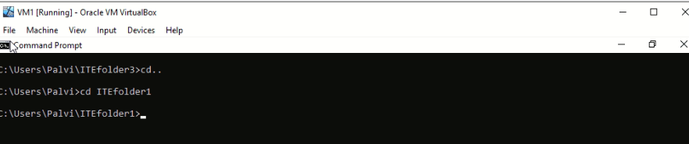

1. Type **echo This is doc1.txt > doc1.txt** at the command prompt. The **echo** command is used to display a message at the command prompt. The **>** is used to redirect the message from the screen to a file. For example, in the first line, the message **This is doc1.txt** is redirected into a new file named **doc1.txt**. Use the **echo** command and **>** redirect to create these files: **doc2.txt**, **file1.txt**, and **file2.txt**.

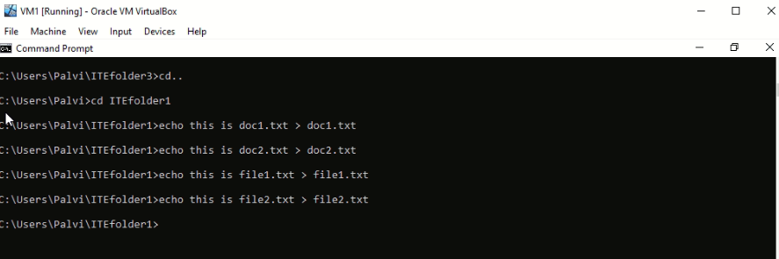

1. Use the **dir** command to verify the files are in the **ITEfolder1** folder.

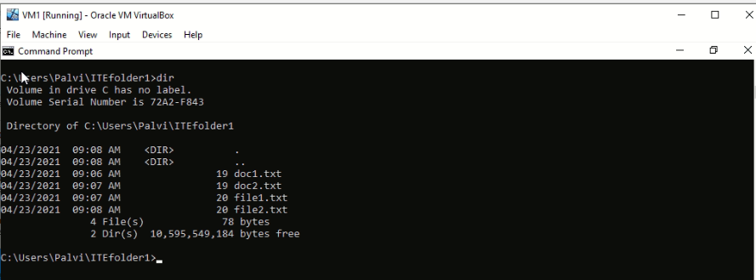

**Step 5: Copy, delete, and move files.**

a. At the command prompt, type **move doc2.txt C:\Users\ITEUser\ITEfolder2** to move the file **doc2.txt** to the **C:\Users\ITEUser\ITEfolder2** directory.

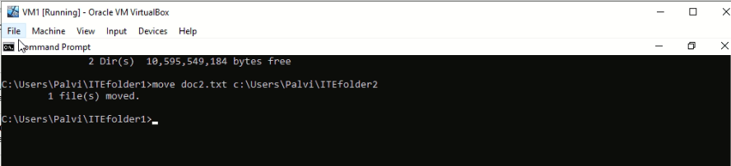

b.Type **dir** at the prompt to verify that **doc2.txt** is no longer in the current directory.

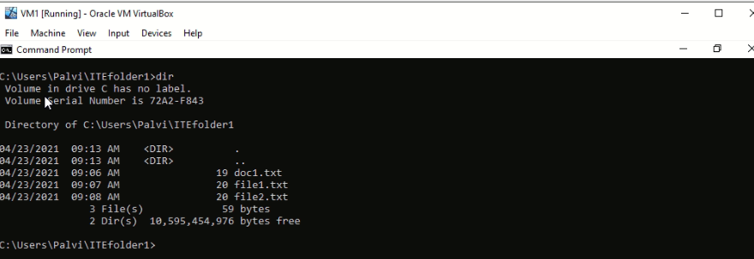

c. Type **cd C:\Users\ITEUser\ITEfolder2** to change the directory to **ITEfolder2**. Type **dir** at the prompt to verify **doc2.txt** has been moved.

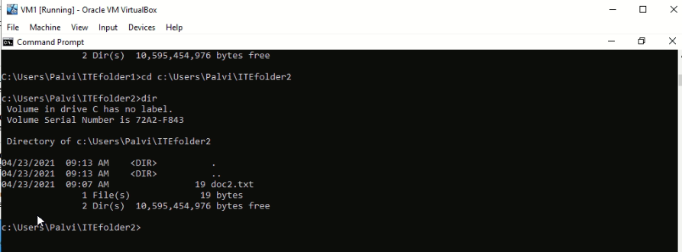

1. Type **copy doc2.txt doc2_copy.txt** to create a copy of **doc2.txt**. Type **dir** at the prompt to verify a copy of the file has been created.

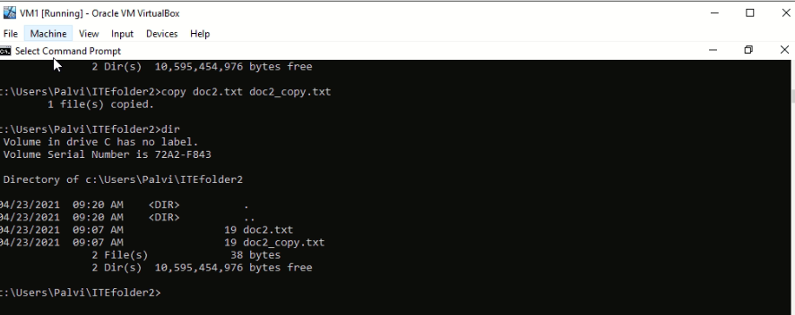

1. Now use the **move** command to move **doc2_copy.txt** to **ITEfolder1**. Type **move doc2_copy.txt..\ITEfolder1**.

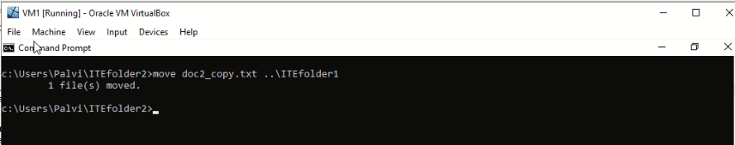

1. A copy of **doc2.txt** can be created and renamed with the **copy** command. Type **copy doc2.txt ..\ITEfolder1\doc2_new.txt** at the prompt.

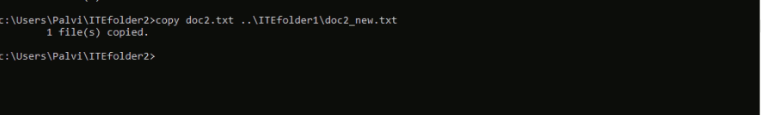

g. Type **dir ..\ITEfolder1** to view the content in **ITEfolder1** without leaving the current directory.

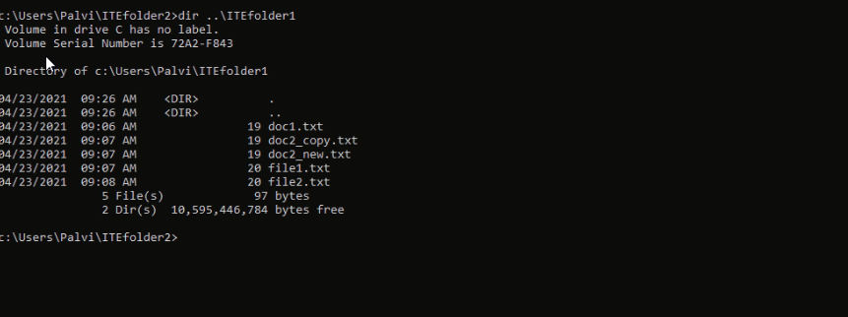

h. Change the current directory to **ITEfolder1**. Type **cd ..\ITEfolder1** at the prompt.

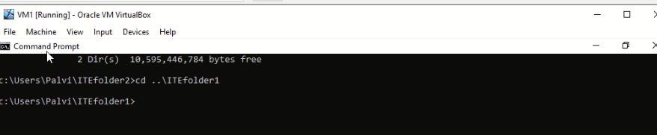

1. Move **file1.txt** and **file2.txt** into **ITEfolder3**. To move all the files that contain the word **file** into **ITEfolder3** with one command, use a **wildcard** (**\***) character to represent one or more characters. Type **move file*.txt ..\ITEfolder3**

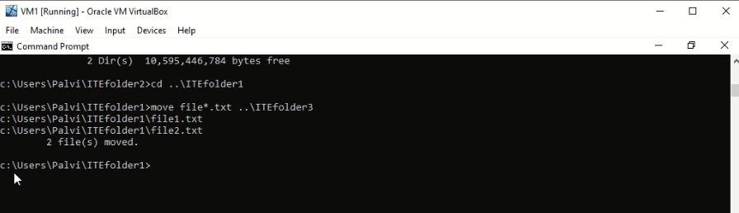

j. Now delete **doc2_copy.txt** from the **ITEfolder1** directory. Type **del doc2_copy.txt**. Use the **dir** command to verify the file deletion.

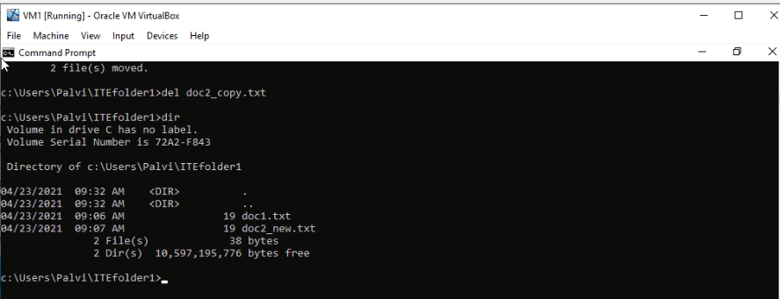

**Step 6: Use the xcopy command.**

1. Verify the content of ITEfolder3. Type **dir ..\ITEfolder3**.

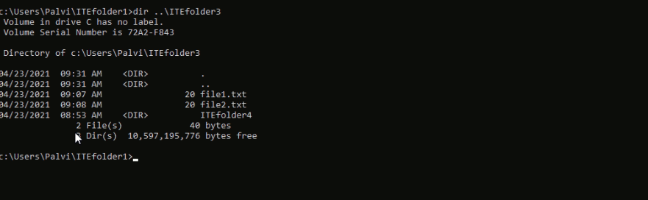

b. Verify the content in **ITEfolder1**. Move all the files in this folder to ITEfolder2. Type **move doc*.txt ..\ITEfolder2** to move the files.

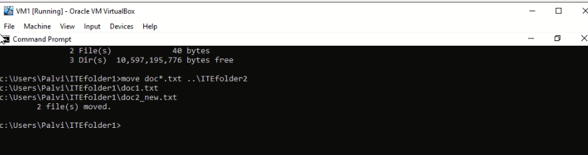

c. Type **xcopy ..\ITEfolder3 .** at the prompt to copy the content of **ITEfolder3** to **ITEfolder1**. Note the **.** at the end of the command. It is a shortcut for the current directory.

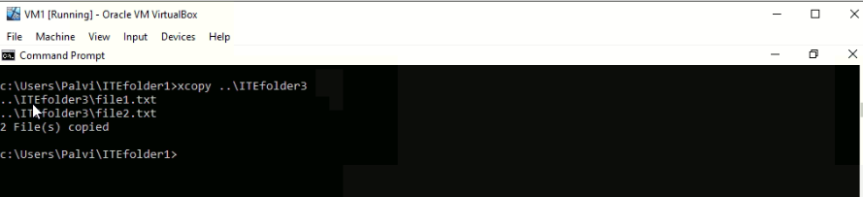

d. At the prompt, type **dir** to display the content of **ITEfolder1**. Only the files in the **ITEfolder3** were copied into **ITEfolder1**. The directory **ITEfolder4** was not copied into **ITEfolder3**.

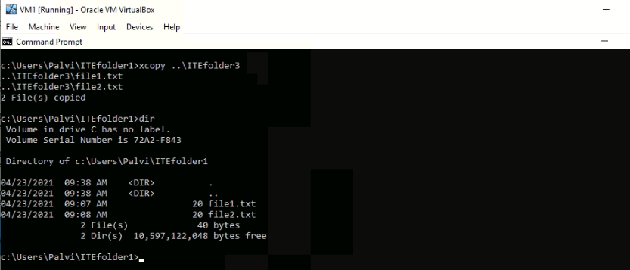

e. Use **help xcopy** to determine which switch would allow the **xcopy** command to copy **all** the files and directories.

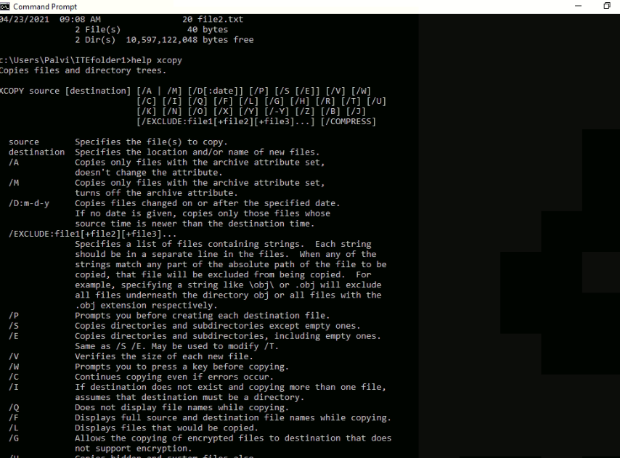

f. Type **xcopy /E ..\ITEfolder3 .** at the prompt to copy the files. When prompted, type **a** to allow overwriting the existing files.

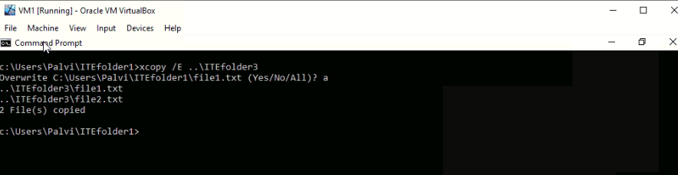

1. Verify the **ITEfolder4** was also copied in **ITEfolder1**.

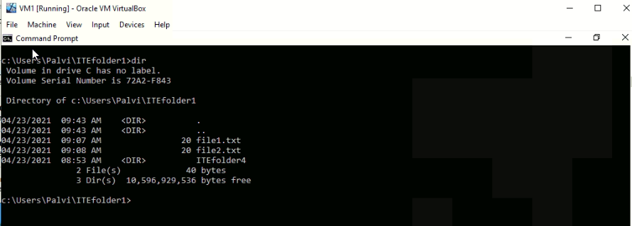

**Step 7: Delete directories.**

In this step, you will delete an empty and a non-empty directory using the **rd** command.

1. Navigate to the **C:\Users\ITEUser\ITEfolder3** directory.

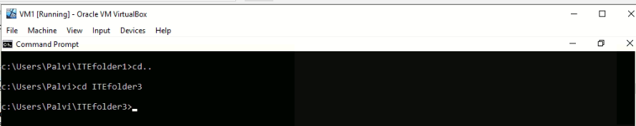

1. Use the **rd ITEfolder4** to delete the empty directory. Verify the directory removal using the **dir** command.

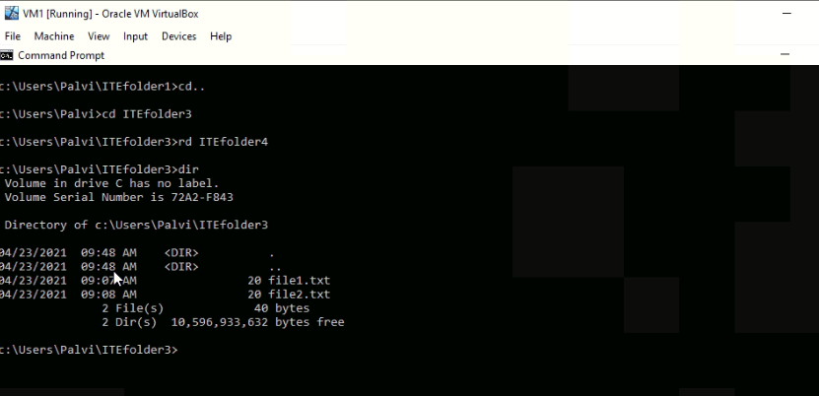

1. Navigate to **C:\Users\ITEUser** folder.

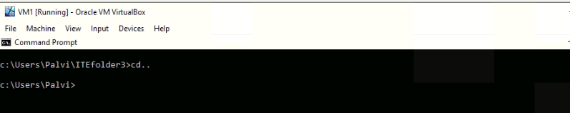

d. Use the **rd ITEfolder2** to delete the non-empty directory. The message indicates that the directory is not empty and cannot be deleted.

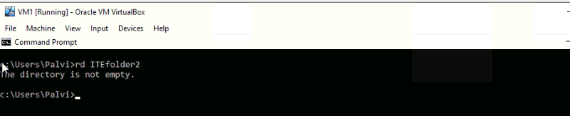

e. Use **rd /?** command to determine the switch that allows the deletion of a non-empty directory.

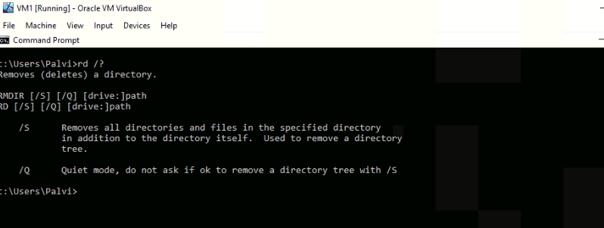

f. Type **rd /S ITEfolder2** to delete this folder. When prompted, type **y** to delete the directory. Use **dir** to verify that **ITEfolder2** was deleted.

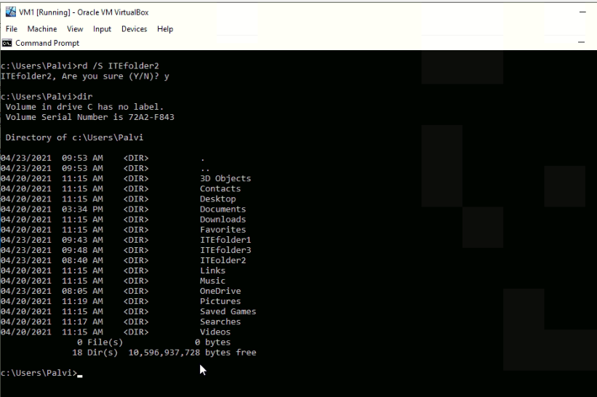

g. Type **exit** to close the command prompt window.